Boston Logan International Airport Benchmarks
- The current capacity benchmark at Boston Logan is 118-126 flights per hour in good weather.
- Current capacity falls to 78-88 flights (or fewer) per hour in adverse weather conditions, which may include poor visibility, unfavorable winds, or heavy precipitation.
- Traffic peaks at Boston can be handled today under good weather conditions when the winds favor the most efficient runway configuration. Peaks are periods of high concentration of arrival and/or departure traffic.
- During adverse weather, capacity is lower and these peaks cannot be handled as well.
- In 2000, Boston was ranked fifth in the country in number of flights significantly delayed (more than 15 minutes). Roughly 5% of aircraft are delayed 15 minutes or longer.
- In adverse weather, capacity is lower and scheduled traffic exceeds capacity 8 hours of the day and the percentage of significantly delayed flights jumps to 12%.
- A new runway, planned for completion in 2005, will not affect the Boston capacity benchmarks. Instead, this runway will help mitigate delays normally encountered during adverse wind conditions when the airport is reduced to a single runway operation today. This assumes that airspace, ground infrastructure, and environmental constraints allow planned use of the runway.
- In addition to the new runway, technology and procedural improvements are expected to increase the Boston capacity benchmark by 4% in both good and adverse weather over the next 10 years.
- These capacity increases could be brought about as a result of:
  - ADS-B/CDTI (with LAAS), which provides a cockpit display of the location of other aircraft and will help the pilot maintain the desired separation more precisely.
  - FMS/RNAV routes, which allow a more consistent flow of aircraft to the runway.
- Demand is expected to grow by 6% over the next decade but delays are not expected to increase primarily due to the construction of the new runway.

Airport Capacity Benchmarks – These values are for total operations achievable under specific conditions:
- Optimum Rate – Visual Approaches (VAPS), unlimited ceiling and visibility
- Reduced Rate – Most commonly used instrument configuration, below visual approach minima

Scenario | Optimum Rate | Reduced Rate
Today | 118-126 | 78-88
New Runway | 118-126 | 78-88
Plus planned improvements | 123-131 | 81-91

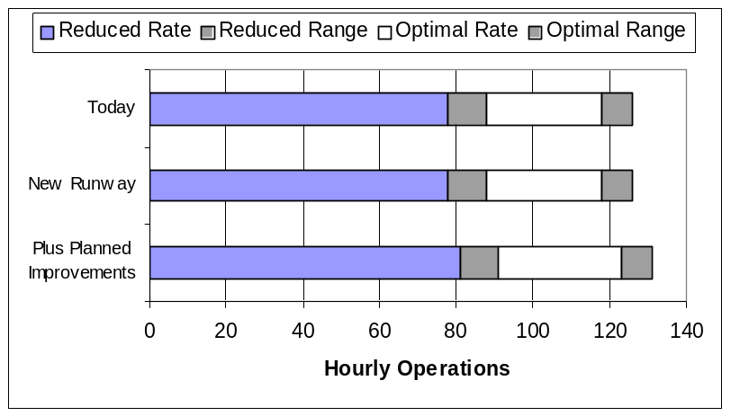
- The benchmarks describe an achievable level of performance for the given conditions, which can occasionally be exceeded. Lower rates can be expected under adverse conditions. Note: In some cases, facilities provided separate unbalanced maximum arrival and departure rates.
- Planned Improvements include:
  - ADS-B/CDTI (with LAAS) – provides a cockpit display of the location of other aircraft. This will help the pilot maintain the desired separation more precisely.
  - FMS/RNAV Routes – allows more consistent delivery of aircraft to the runway threshold.
- Benefits from Planned Improvements assume that all required infrastructure and regulatory approvals will be in place. This includes aircraft equipage, airspace design, environmental reviews, frequencies, training, etc. as needed.
- Note: These benchmarks do not consider any limitation on airport traffic flow that may be caused by non-runway constraints at the airport or elsewhere in the NAS. Such constraints may include:
  - Taxiway and gate congestion, runway crossings, slot controls, construction activity
  - Terminal airspace, especially limited departure headings
  - Traffic flow restrictions caused by en route miles-in-trail restrictions, weather or congestion problems at other airports

These values were calculated for the Capacity Benchmarking task and should not be used for other purposes, particularly if more detailed analyses have been performed for the individual programs.
The list of Planned Improvements and their expected effects on capacity does not imply FAA commitment to or approval of any item on the list.

Current Operations – Optimum Rate
- Visual approaches, visual separation – Runway 4R, 4L, 9
- Optimum rate of (68,50) was reported by the facility
- ASPM data is actual hourly traffic counts for the month of April 2000 (and for July/August 2000) for Visual Approach conditions. This data includes other runway configurations and off-peak periods.
- Solid line represents the calculated airport capacity during a busy hour, and the tradeoff between arrivals and departure rates
- The capacity model can only approximate the complex operations at BOS
- Demand at BOS may reach or exceed the calculated capacity during short periods (15 minutes) during busy hours
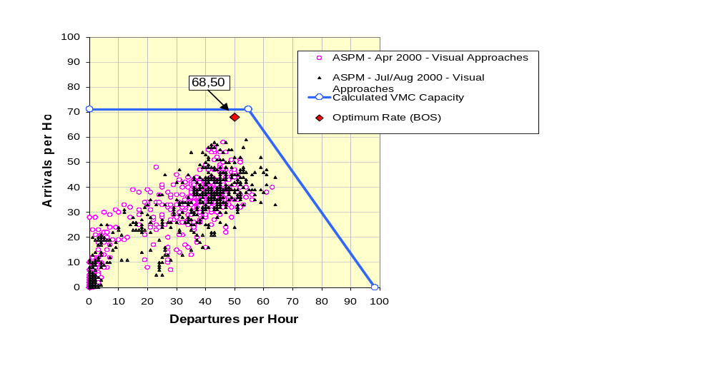
Each dot represents one hour of actual traffic during April 2000
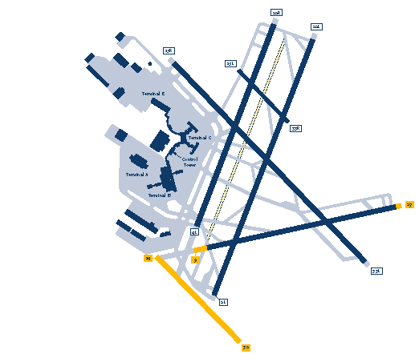

Scheduled Departures and Arrivals and Current Departure and Arrival Rate Boundaries (15-Minute Periods) Under Optimum Rate Conditions

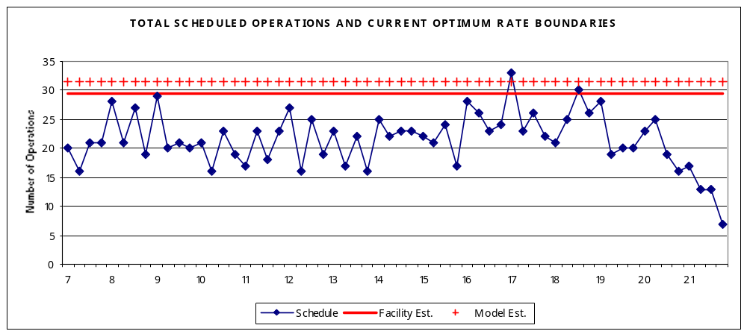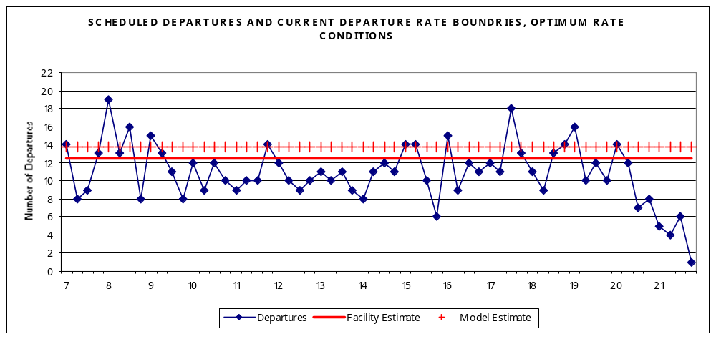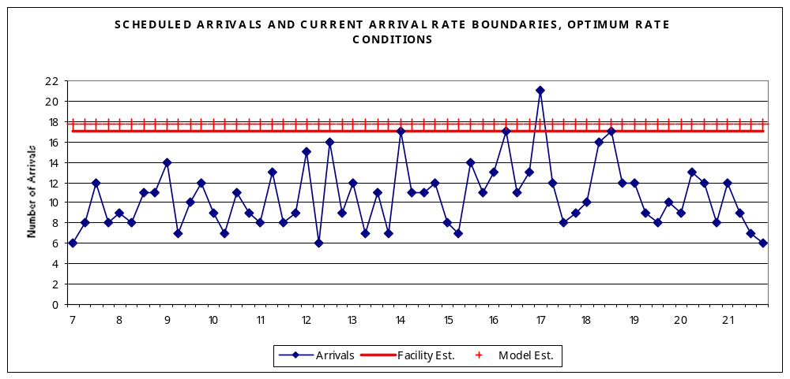

Current Operations – Reduced Rate

- Instrument approaches (below Visual Approach Minima) – Runway 33L/R, 27
- Hourly rate of (44, 44) was reported by the facility
- ASPM data for “Instrument Approaches” can include other configurations or marginal VFR, with higher acceptance rates
- The capacity model can only approximate the complex operations at BOS
  - Model results assume 6 arrivals and 6 departures per hour on Runway 33R, as reported by the facility
- Chart below represents observed traffic and expected rates in terms of operations per hour
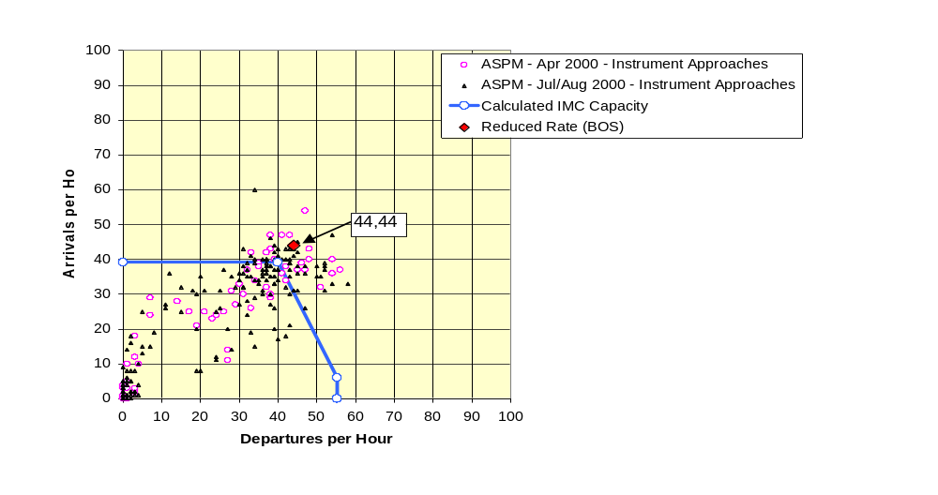

Scheduled Departures and Arrivals and Current Departure and Arrival Rate Boundaries (15-Minute Periods) Under Reduced Rate Conditions

